Day 1  Monday  Arrival | Afternoon check in at Dublin Airport. Depart for Rome with Aer Lingus on three hour flight to Rome. Transfer to the Irish College in the city centre.
Day 2  Tuesday  St John Lateran Colosseum  St Mary Major | Morning Mass in the Irish College Chapel, followed by a visit to the Cathedral of Rome, St John Lateran Basilica. We will enter by the Holy Door opened for the Jubilee Year. The church contains the heads of St Peter and St Paul, as well as works of art accumulated over the centuries. Visit the Colosseum, where we will have a tour from the outside. This amphitheatre was built in the late first century AD and is considered consecrated by the blood of the martyrs. Free time for lunch and a rest. At 4.30 pm. visit St Mary Major Basilica, the principal Marian church in Rome (again we will enter by the Holy Door). Buffet dinner at the Irish College.
Day 3  Wednesday  Papal Audience, Subiaco, Night tour | After breakfast, we will make our way to St Peter’s for an audience with the Holy Father (depends on his health/schedule and cannot be guaranteed). Afternoon excursion to the beautiful monastery of Subiaco in the hills of Eastern Lazio where St Benedict founded his order. Return to College. Free time for dinner. Night tour by coach. During the tour we will stop at the Campidoglio Square for great views of the Roman Forum.  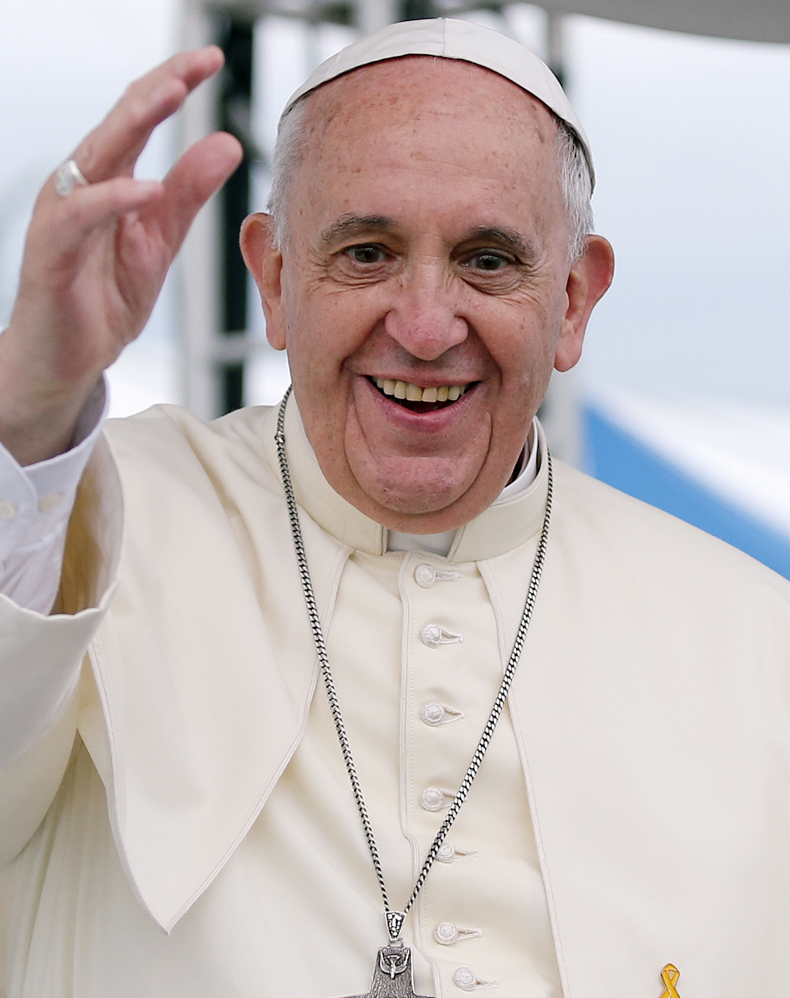
Day 4  Thursday  St Peter’s Basilica Baroque Squares of Rome | Early morning Mass in St Peter’s Basilica. After Mass we will pay our respects at the tombs of St Peter, St John Paul II, St John XXIII, Blessed Paul VI, and many other popes. After our tour, the coach will drop us along the Tiber. We will visit the Pantheon, Rome’s best preserved ancient temple, now a church. Free time for lunch in the area. After lunch call to the tomb of St Catherine of Siena in Santa Maria Sopra Minerva. Visit the beautiful Piazza Navona and the church of Santa Maria dell’ Anima where Irish Martyr Conor O’Devaney was consecrated Bishop of Down and Connor in the 1600s. Return to the Irish College for a free evening.  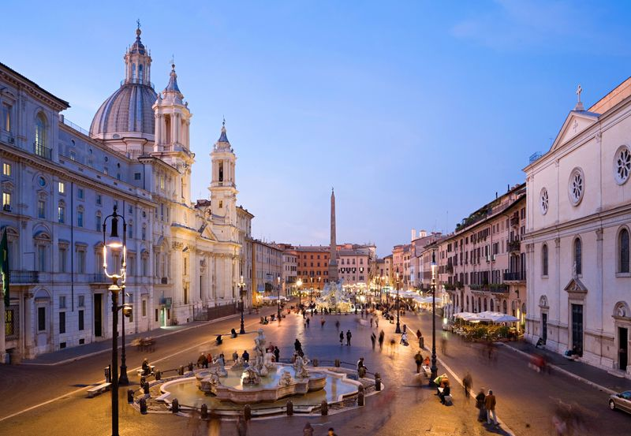
Day 5  Friday  St. Stefano Rotondo  Trevi Fountain  Catacombs  St.Paul’s Basilica | A walk to the nearby church of Santo Stefano Rotondo to visit the tomb of the son of Brian Boru, Donnchadh, who died in Rome in 1064. Time for shopping and lunch in the area of the Trevi Fountain. Continue to the Catacombs of St Callixtus where we will have a tour of this ancient cemetery with its early samples of Christian art. Mass. Visit St Paul’s Outside the Walls and pay our respects at the tomb of the Apostle to the Gentiles (entering once again by the Holy Door). Return to the Irish College. Free evening. An optional walking tour in the area of the Spanish Steps will be organised for those interested.
Day 6  Saturday  Departure | After breakfast, transfer to Fiumicino Airport. Check in at 9.30 am for 12pm flight to Dublin.

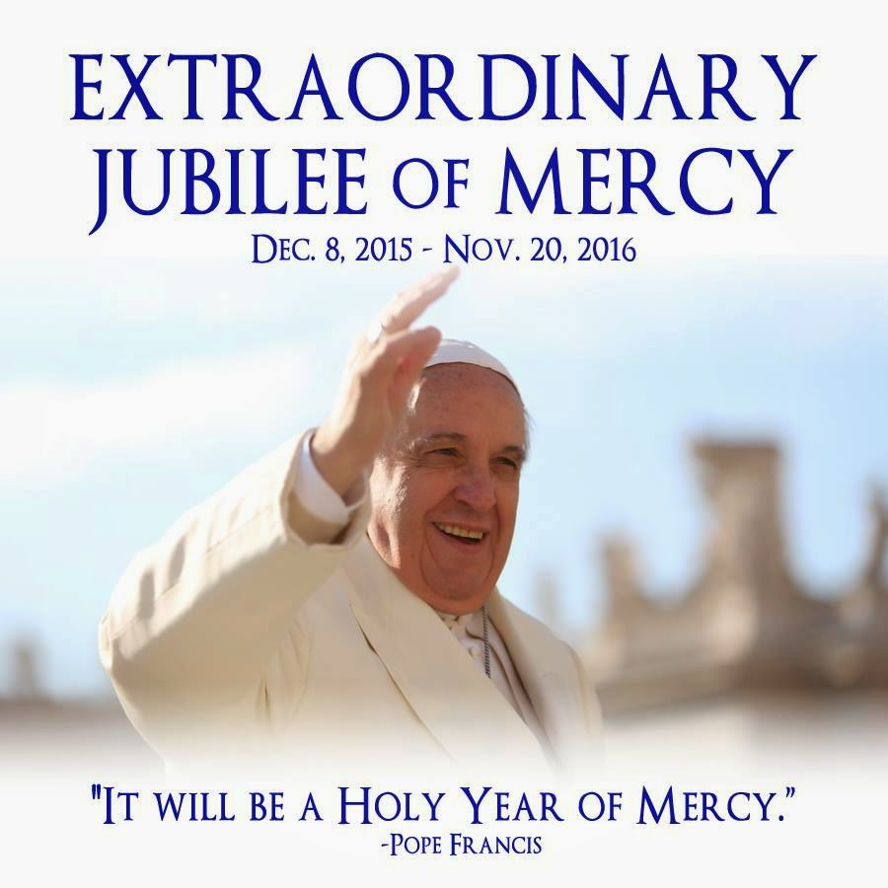

Price: € 849 per person sharing

Included in the price:
- Aer Lingus flights Dublin to Rome and return with 15kg checked-in bag.
- 5 night accommodation in the Pontifical Irish College in air-conditioned, en-suite rooms, on a bed & breakfast basis.
- 1 buffet dinner at the Irish College
- Full time accompaniment by a Cultural Connections tour leader.
- Coaching for all the excursions mentioned on the itinerary
- Guided tours of all places visited
- All taxes (governmental and local).
PLEASE NOTE – The itinerary is a sample itinerary only and is subject to change
Extras
- Entrance fee to Catacombs (€8).
- Single room supplement of €25 euro per night. Single rooms are limited and on a first come first served basis.
- Travel insurance. We highly recommend travel insurance. If you don’t already have travel insurance you can purchase it from us at the following prices:
18yrs – 69yrs: €20
70yrs – 74yrs: €40
75yrs– 79yrs: €50
80 + yrs: €60
HOW TO BOOK:
1. Obtain a booking form from your group leader or phone us at 0579355050.
2. Fill out your booking form having read our Terms & Conditions available online at www.cuturalconnections.eu
3. Submit the deposit of €300 made out to Tom Mannion Travel and booking form to: Cultural Connections Ltd. Newtown, Rahan, Tullamore, Co. Offaly.

